CPE301 – SPRING 2019

Design Assignment 4A

Student Name: Robert Sander

Student #: 5002102412

Student Email: sander1@unlv.nevada.edu

Primary Github address: <https://github.com/sanderUNLV/submission_DA.git>

Youtube link: <https://youtu.be/_bEjB1l42tg>

1. **COMPONENTS LIST AND CONNECTION BLOCK DIAGRAM w/ PINS**

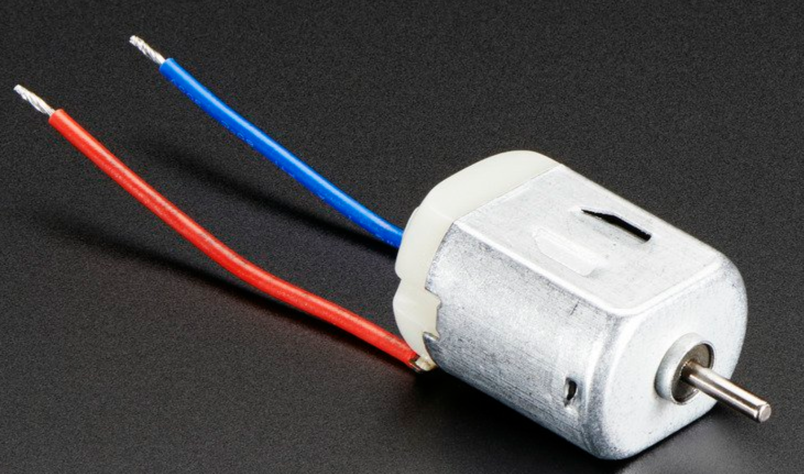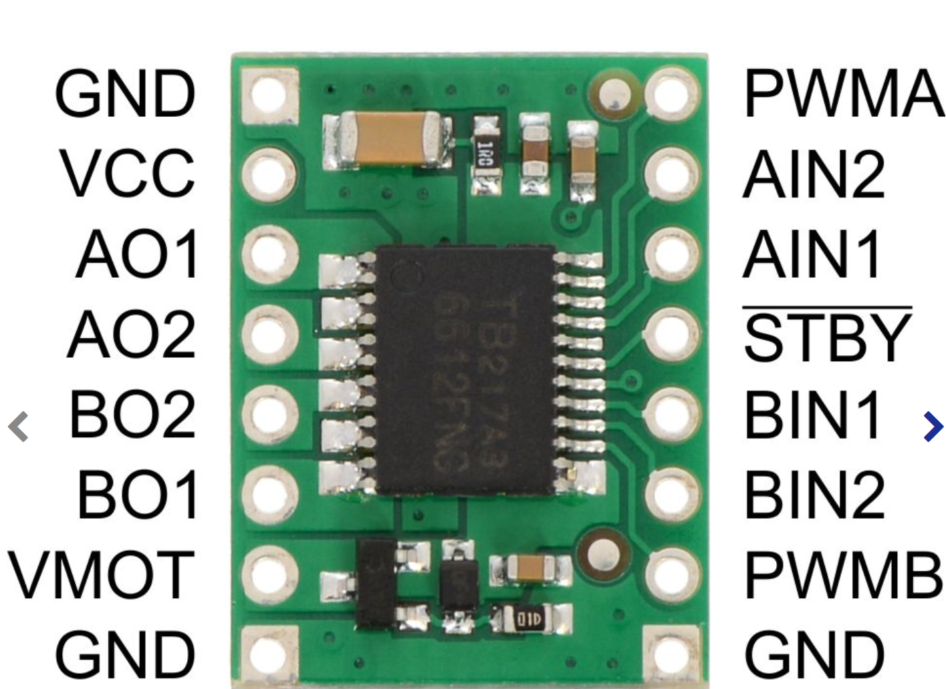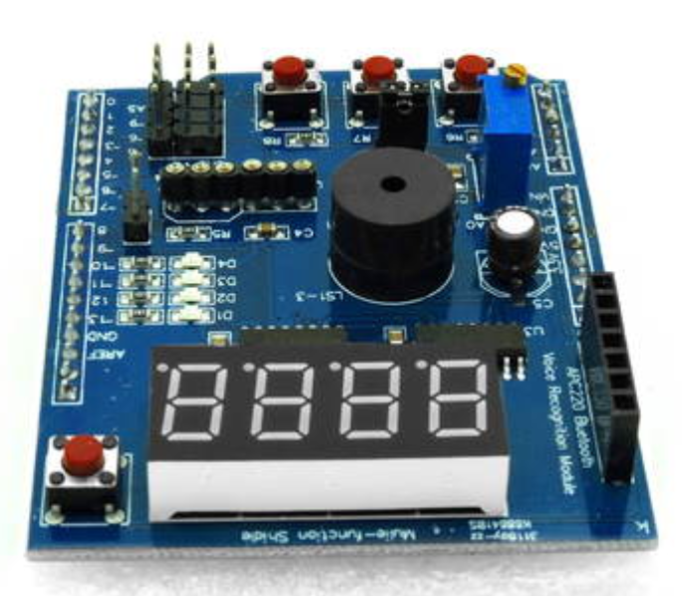

*Figure 1 – DC Toy Motor, TB6612FNG Dual Motor Driver, and Arduino Multi-Function Shield*

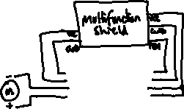



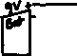

*Figure 2 –Schematic*

1. **INITIAL/MODIFIED/DEVELOPED CODE OF TASK 1/A**

// DA4A_C

// Author : Robert Sander

#define *F_CPU* 16000000UL

#include <avr/io.h>

#include <util/delay.h>

#include <avr/interrupt.h>

int main (void)

{

PCMSK1 = (1<<PCINT9); // Set PC.1 as the interrupt pin

PCICR = (1<<PCIE1); // For PCINT[14:8]

sei(); // enable interrupts

DDRC |= (0<<3)|(0<<2)|(0<<1);

DDRB |= 0xFE; //ALL BITS AS OUTPUTS EXCEPT PB.0

PORTB |= 0x3E; // TURN "OFF" LED PB.2-5 0011 1110

ICR1 = 0xFFFF; // set TOP to 16bit

TCCR1A |= (1 << COM1A1)|(1 << COM1B1); // set none-inverting mode

TCCR1A |= (1 << WGM11);

TCCR1B |= (1 << WGM12)|(1 << WGM13);

// set Fast PWM mode using ICR1 as TOP

TCCR1B |= (1 << CS10); // START the timer with no prescaler

while(1) //infinite loop

{

if(!(PINC & (1<<PINC2))) //If switch PC.2 is pressed

{

PORTB = ~(1<<4); // TURN PB.4 LED ON

OCR1A = 13108; // 65536*(0.20)=13107.2

// set PWM for 20% duty cycle @ 16bit

// keep motor at 20% speed

}

if(!(PINC & (1<<PINC3))) //If switch PC.3 is pressed

{

PORTB &= (1<<4)|(1<<3)|(1<<2);

PORTB = ~(1<<5); // TURN PB.5 LED ON

OCR1A = 62260; // 65536*(0.95)=62259.2

// set PWM for 95% duty cycle @ 16bit

//keep motor at 95% speed

}

}

}

ISR(PCINT1_vect) // SET PCINT9 TO STOP THE MOTOR

{

PORTB = (1<<5)|(1<<4)|(1<<2);

PORTB &= ~(1<<3); // TURN PB.2 LED ON

OCR1A = 0; // stop motor using interrupt

}

1. **SCREENSHOTS OF EACH TASK OUTPUT**

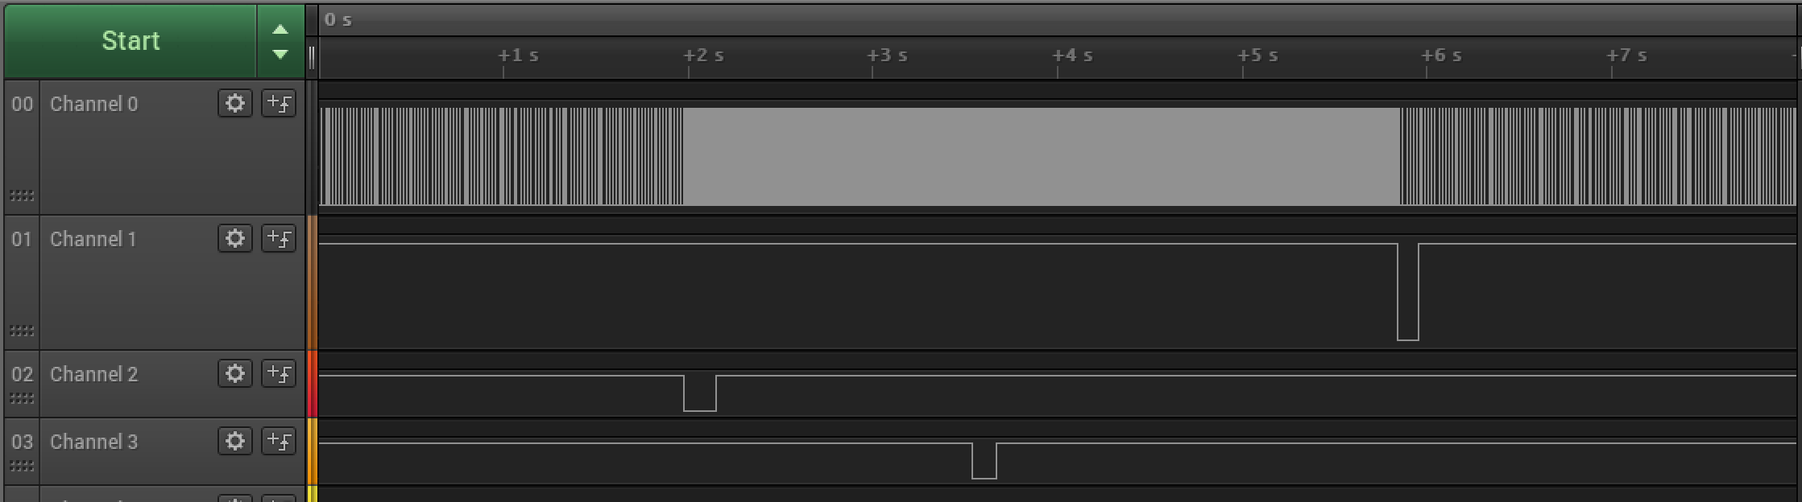

*Figure 3 – Logic Analyzer Waveform*

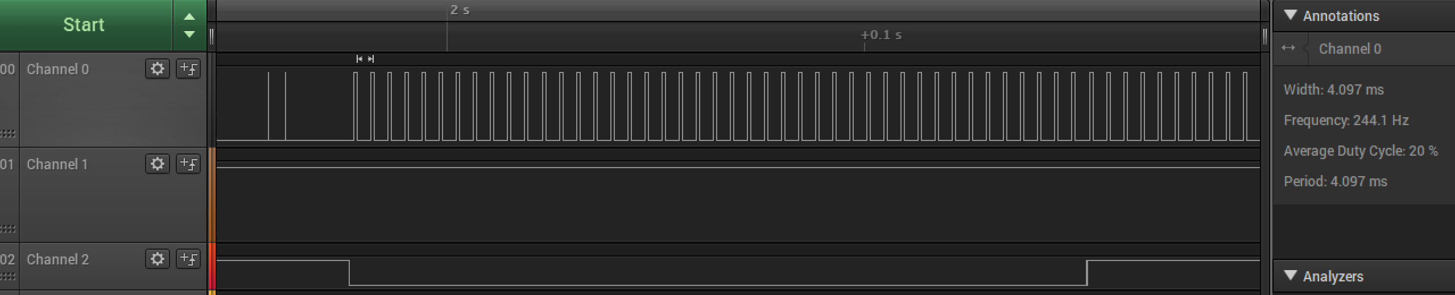

*Figure 4 – Switch 2, 20% duty cycle*

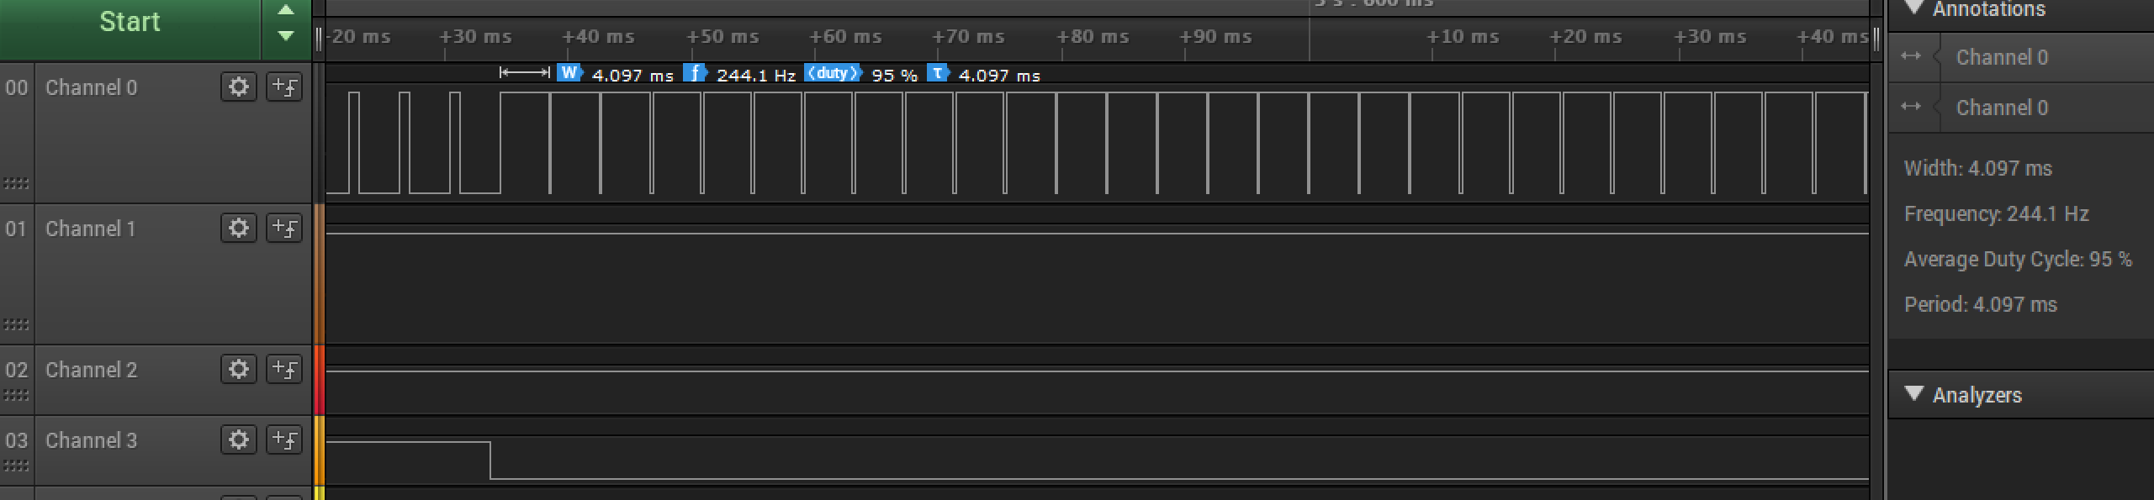

*Figure 5 – Switch 3, 95% duty cycle*

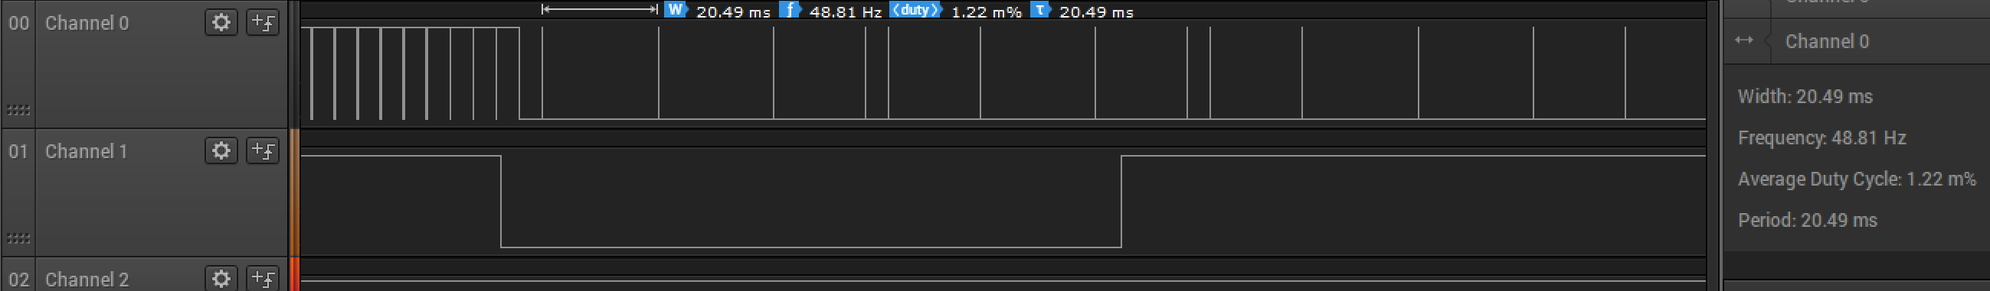

*Figure 6 – Switch 1, 0% duty cycle*

1. **SCREENSHOT OF EACH DEMO (BOARD SETUP)**

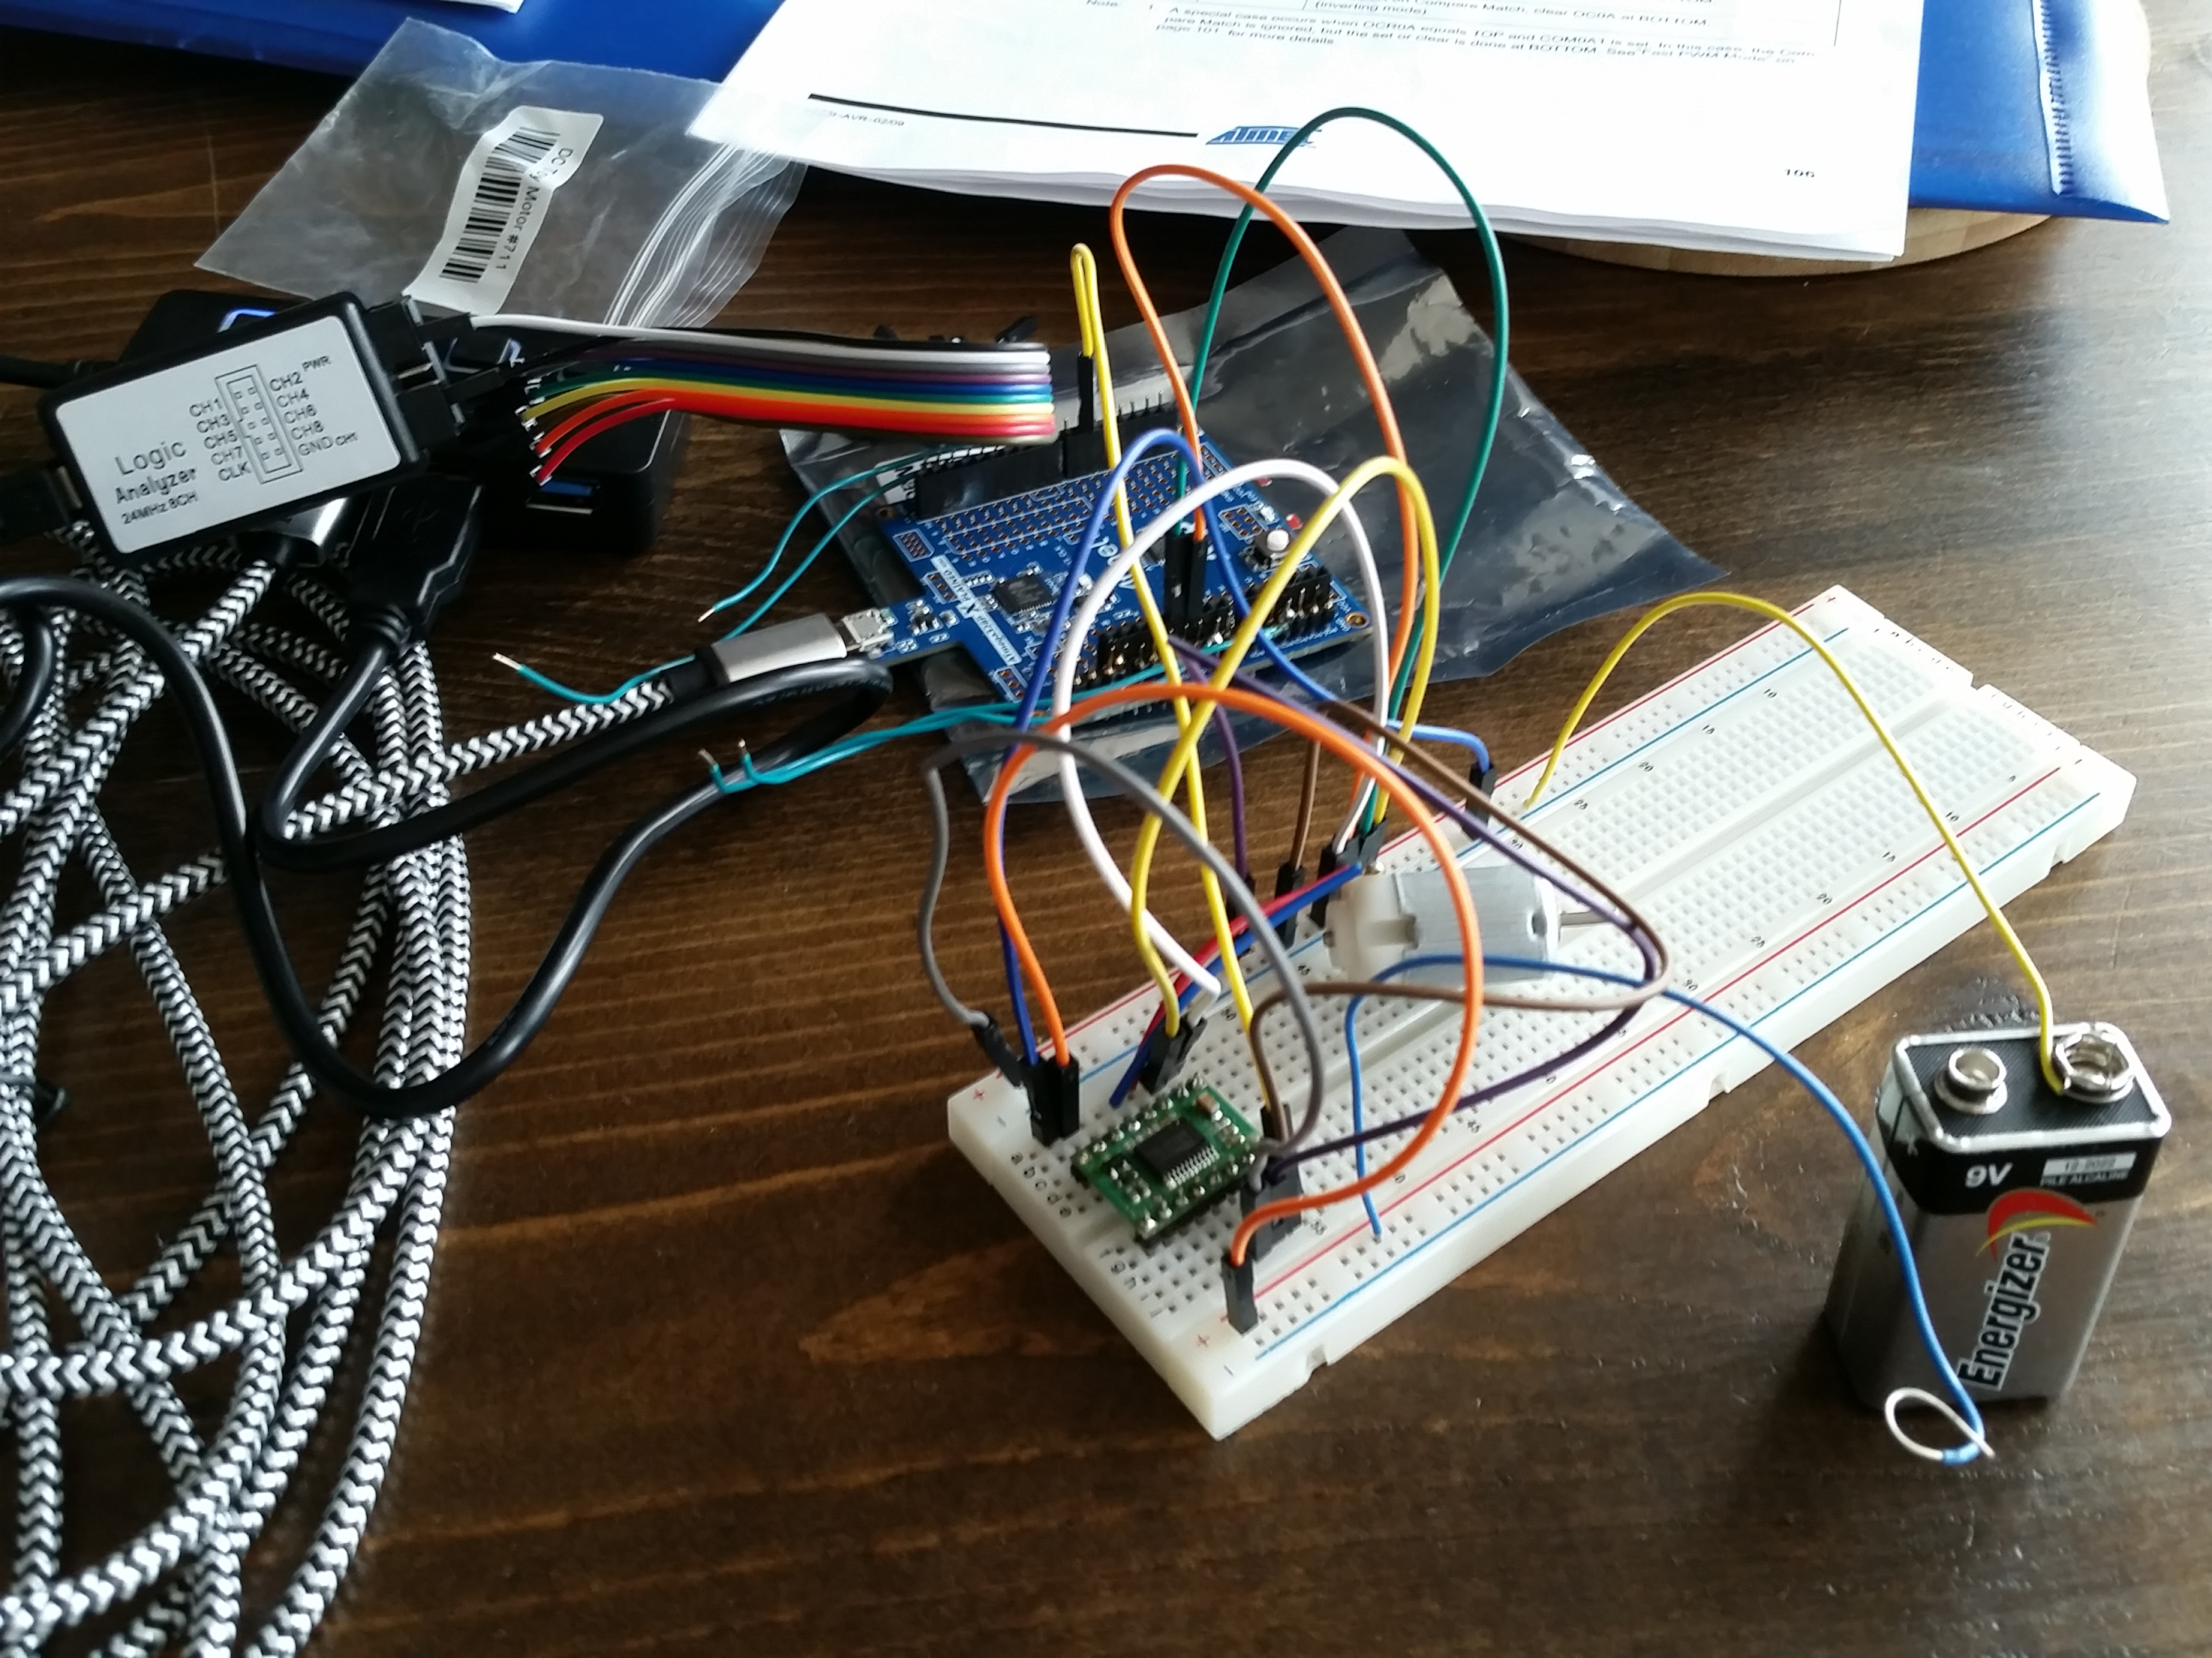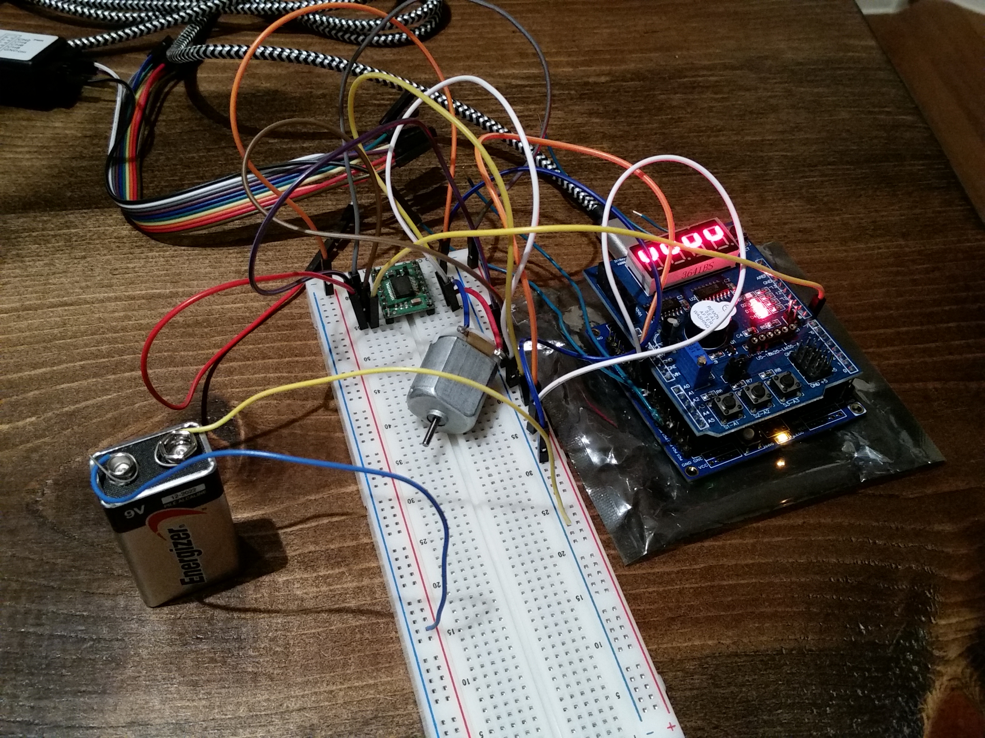

*Figure 7 – Task Setup, Multifunction Shield, Motor, Driver, and Battery*

1. **VIDEO LINKS OF EACH DEMO**

<https://youtu.be/_bEjB1l42tg>

1. **GITHUB LINK OF THIS DA**

<https://github.com/sanderUNLV/submission_DA.git>

**Student Academic Misconduct Policy**

<http://studentconduct.unlv.edu/misconduct/policy.html>

“This assignment submission is my own, original work”.

-Robert Sander